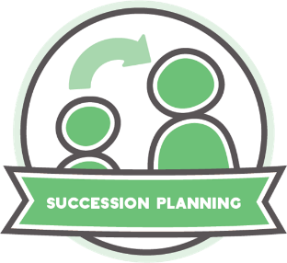

Worksheet: Succession planning

It’s what you know and who you know!
Assessing business-critical risk
What are your key internal and external responsibilities? There might be risks involved in delegating these, or in holding on to them. Use the table below to help inform succession planning and capacity building.

My key responsibilities
Internal  e.g. line management, planning, development. | Opportunities or risks involved in delegating | Opportunities or risks involved in not delegating | Reflections and actions

External  e.g. communications, reporting, partnerships, funding, relationships. | Opportunities or risks involved in delegating | Opportunities or risks involved in not delegating | Reflections and actions

